



|  |  |
| --- | --- |
| **IM3080 Design and Innovation Project****(AY2020/21 Semester 1)****Project Report** | |
| Title: | StudyBee |
| GitHub: | <https://github.com/DIP-Group5-StudyBee/StudyBeeGroup5> |
| Submitted by: | Goh Jun Bin |
| Guo Jiangxiao |
| Jack Teo |
| Koh Sze Chee |
| Leo Boon Yin, Wayne |
| Lyu Songyu |
| Ng Xin Ping |
| Tan Zhen Ye, Bryan |
| Tang Kaiyi |
| Tey Rui Jie |
| Wee Yuheng, Latrecia |
| Supervisor: | Assoc Prof Mohammed Yakoob Siyal |

# Table of contents

Contents

**IM3080 Design and Innovation Project** 1

**(AY2020/21 Semester 1)** 1

**Project Report** 1

Table of contents 2

**1.** **Background and Motivation** 4

1.1 Background 4

1.2 Motivation 5

**2.** **Objective** 5

2.1 Design statement 5

2.2 Target audience 5

**3. Review of Technology** 6

3.1 Analysis of available study apps 6

3.2 Alternative study aids 7

3.3 Market Gap 7

**4. Design and Implementation** 7

4.1 Design Consideration / Choice of components 7

4.1.1 Registration, login and user profile 8

4.1.2 Lobby-based System with Rooms 8

4.1.3 Group finder methods via Quick join or Lobby listings 9

4.1.4 Interface with a third-party video conferencing app 9

4.1.5 Room history 10

4.1.6 Friend list 10

4.1.7 Development process – Waterfall Methodology 10

4.2 Final Design 11

4.2.1 User Experience for Student and TA 11

4.2.2 Database Diagram 11

4.2.3 Use-Case Diagram 11

4.3 Implementation and Coding 11

4.3.1 TA Privilege - Breakout Room 12

4.3.2 Lobby list 12

4.3.3 Quick/ random join 12

4.3.4 Zoom API 12

4.3.5 Searching for users to add as friends 13

**5. Conclusion and Recommendation** 13

5.1 Conclusion 13

5.2 Recommendation for Future Works 14

**6. Appendices** 15

Appendix A. User Experience Diagrams 15

Students 15

TA 15

Appendix B. Database Diagram 16

Appendix C. Use-Case Diagram 16

Appendix D. Wire framing 17

Appendix E. Prototyping 22

Appendix F. Final Design 24

Appendix G. Source Code 27

SDK initialization 27

Schedule meeting 31

Breakout Room 38

Appendix H. User Guide 40

Poster and virtual showcase 40

Promotional video 41

# **1. Background and Motivation**

## 1.1 Background

Throughout the COVID-19 global pandemic, the crisis has forced the hands of many into unfamiliar situations in the name of health and safety. Countries around the world took up measures such as nation-wide lockdowns, usage of masks and social-distancing. Singapore was not exempt from this, enforcing circuit-breaker and Safe Management Measures to prevent the spread of the infectious disease. To this day, businesses and schools have been disrupted to some extent, in order to comply with these government-mandated measures. In Nanyang Technological University (NTU), the second semester of AY19/20 was prematurely concluded, cancelling most exams and urgently calling back students from exchange programs.

Upon resumption of school activities in the new semester, additional measures for social-distancing were added such as:

* Mandatory check-in and temperature taking stations for contact tracing
* Hybrid-learning, where a class is conducted to an audience of online and physically attending students
* Blocking out of tables and seats

While these measures have been undoubtedly necessary for the upkeep of public safety, it has also **compromised the productivity and convenience** of many.

## 1.2 Motivation

As students from NTU, the team has experienced the drawbacks of these safety measures firsthand, and took great interest in easing the circumstances for our peers and ourselves. Therefore, we decided to look into these issues and try to offer a meaningful solution towards **online learning**.

One of the main problems identified was the **difficulty of holding group study sessions** due to the physical limitations brought on by social distancing, since fellow peers were often not in school and public spaces have been made less available to prevent overcrowding.

This was a design opportunity for the team to present a solution towards improving the productivity and convenience of students during the COVID-19 climate.

# **2. Objective**

## 2.1 Design statement

Therefore, our objective was to design and create a mobile application that allows for students to meet like-minded people, form study groups, congregate virtually and have study sessions through the mobile app. The app should also offer user agency via the freedom to curate their own experience, by choosing the style of study and the kind of people they interact with.

## **2.2 Target audience**

The app is primarily designed for students who wish to study or have discussions with others via a virtual platform, mainly due to having to adapt from physical to virtual group study habits as a result of the COVID-19 climate. Additionally, academic staff such as teaching assistants (TA) and professors are also encouraged to use the app to provide their valuable insight to these students. While the app would generally be suitable for all students, it is designed especially for NTU students and staff during this project phase, to keep the scope manageable enough and have a user base of similar educational backgrounds. Therefore, with such a moderately large target audience, the app should be equipped with a User Interface (UI) that would appeal to a broad spectrum of users and have a sufficiently streamlined User Experience (UX), simple and intuitive enough for users to pick up promptly.

# **3. Review of Technology**

## 3.1 Analysis of available study apps

While a quick search across the internet may display an abundance of “study buddy” styled apps, such as the “Study Buddy” app by Lion Technologies [1], a lot of these apps are mostly catered towards self-study habits and do not focus on offering means for users to find study partners or study groups. They also do not offer methods, other than a messaging tool, to utilise a virtual space for study sessions via the app. Therefore, these apps tend to resemble more of a personal study journal to mark study progress rather than serve as a social networking platform to find study partners.

Another example of a Study Buddy app is the “StudyBuddy” by Nathanial Blumer, which is available in the Apple App Store [2]. While this app allows the user to find a study partner, the app does not have a focused audience and did not gain traction, resulting in the app not working as per intended due to a lack of users and features.

[1] Study Buddy app by Lion Technologies is available at: <https://play.google.com/store/apps/details?id=com.lionapp.studybuddy>

[2] StudyBuddy app by Nathanial Blumer is available at: <https://apps.apple.com/us/app/studybuddy/id948997336>

## 3.2 Alternative study aids

The use of Telegram (messaging platform app) study groups is popular amongst many NTU students to find study partners or study tips. However, with the application being mainly a messenger app, there is a limitation to the activities available, and students would have to bring their study activities outside of the app. These study groups also tend to be large (often about hundreds of participants) with no easy way of filtering preferred study characteristics and can be daunting for a user to participate in active discussion with a high amount of strangers. Therefore, while such an app can be great for disseminating information and tips, the app does not offer a streamlined way to look for partners to revise or study on the same subject.

## 3.3 Market Gap

Therefore, there is a market opportunity for a study buddy finder app which matches students for the purpose of scheduling and facilitating an online group study session, unlike the currently available mobile apps which are unable to serve these purposes.

# **4. Design and Implementation**

## 4.1 Design Consideration / Choice of components

With one of the stipulations requiring this project to be fully software based, it also inspired the implementation of this project to be on a mobile platform, to allow for ease of accessibility. The app is called ‘**StudyBee**’ as a play on words referencing ‘Study Buddy’, and to also have a cartoon bee mascot, as part of the brand identity.

Therefore, based on our objective and identified market gap, we designed the app to include the following core functions:

1. **Registration, login and user profile** for personal profile setup and authentication
2. **Lobby based system with rooms** to congregate study group members
3. **Group finder methods via Quick join or Lobby listings** to allow the user to search for a study group based on user’s preferred study style
4. **Interface with a third-party video conferencing app** to serve as an online platform for group studying and discussion
5. **Room history** for potential recurring meetings and to review past study records
6. **Friend list** to allow users to search, save and contact each other outside of the app

### 4.1.1 Registration, login and user profile

Since the app is intended for NTU personnel, authentication of the user is needed. Therefore, for a user registration to go through, the registrant must provide an email address with the domain of an NTU Outlook email (@e.ntu.edu.sg). The user is also required to provide basic personal particulars such as name, faculty, and course, which would serve as “tags” for the room system. These basic information can be seen by other users as part of the user’s personal profile page. While it may be good to have user information such as GPA, ultimately, we decided that such information was sensitive and not necessary for the purpose of the app. The option of segregation based on GPA would have turned users away and might promote a toxic or elitist environment.

### 4.1.2 Lobby-based System with Rooms

The app is based on a room creation and room joining system, where a user would specify his ideal requirements for the room based on his room description and preferred study group characteristics (study style, group size, TA requirement and requirement to have participants from the same course). Upon creation of the room, the room will be listed in the lobby together with other rooms.

### 4.1.3 Group finder methods via Quick join or Lobby listings

With the created rooms listed in the lobby, other users may opt to join rooms based on their preferences. In the event where the user is open to all study group types and just wants to join any room, he may use the quick join function, which will allocate him to the latest created room. The Quick join function would also alleviate the potential problem of having a lack of app users, as students may end up being too shy or indecisive to join a room. Upon filling up the room limit, no further participants would be allowed enter the study session until a current participant vacates his/her slot. This is to comply with the room creator’s group preference, where the preferred group size was set during room creation.

### 4.1.4 Interface with a third-party video conferencing app

With considerations to the tight working schedule and risk of working on something beyond our expertise, we decided to use a more efficient method of integrating a third-party app to fulfil the app’s needs. Since we want users to be able find a study group and proceed to study with them online, we decided to utilise the API of the popular app, Zoom, to facilitate the use of video chat and screen sharing functions within the StudyBee app. Upon room creation, the user would be asked to sign into Zoom where he can schedule a Zoom meeting for the created room. Users who enter the room to be part of the study group will then be connected to Zoom to participate in the study session and take up one vacancy slot in the room.

As per Zoom’s procedures, the StudyBee room creator will be the default room host of the Zoom session and has additional privileges in the room such as the ability to set a password or kick any users. Therefore, this can be a form of incentive for users to take up the role of a host and create StudyBee rooms.

These meetings can be scheduled for future timings or even for physical meetups, as long as the room creator puts up an accurate StudyBee room description, and the room joiners book a slot by joining the room in advance.

### 4.1.5 Room history

The room history of each user is also recorded and displayed in the app. This can be useful for the user to review his/her own study patterns or decide whether a certain schedule works best, based on personal past experiences with the app. The user may plan for recurring or future meetings with reference to this record.

### 4.1.6 Friend list

In the StudyBee app, the user may also search and add other users to a friend list. The friend list would display basic information such as the name and email of the added person, where the main purpose is to serve as a way for the adder to communicate and link up outside of the app. It is also a good way to have repeat sessions with users which they have had positive experiences with.

### 4.1.7 Development process – Waterfall Methodology

Regarding the development process of StudyBee, we adopted the waterfall methodology as it has a linear sequential flow requiring the completion of one phase before moving on to the next phase. The main reasons for the usage of this model is due to the ease of implementation and division of labour. The waterfall model consists of 6 phases namely requirement analysis, system design, implementation, testing, deployment, and maintenance. For this project, we worked towards the deployment phase as completion, which would refer to the final presentation.

## 4.2 Final Design

The development and progression of the StudyBee app, including the wireframing and prototyping stages, can be observed from Appendix D and E, respectively.

The final product of the StudyBee app can be observed from Appendix F.

### 4.2.1 User Experience for Student and TA

Refer to Appendix A for User Experience Diagrams.

### 4.2.2 Database Diagram

Refer to Appendix B for the Database Diagram illustrating the database variables.

### 4.2.3 Use-Case Diagram

Refer to Appendix C for Use-Case Diagram.

## 4.3 Implementation and Coding

For the development of StudyBee, we decided to use the Android Studio Software Development Kit (SDK) and WampServer database. Android Studio and Java language were used due to familiarity from past University modules. WampServer was recommended by group members from experience, as it had a comprehensive overview and display of database variables. The Wamp database server uses php files coded in JavaScript Object Notation (JSON) and uses the IP address to establish connections to the server. The SQL commands will then be inserted to the php files. The conversion of JSON to Java will be done in Android Studio thus allowing the application to display the retrieved data.

### 4.3.1 TA Privilege - Breakout Room

As TAs users are tagged separately in the app, they will be required to register differently from students. Only TA users can utilise the Breakout Room function to move selected participants into separate isolated rooms for privacy. Originally, the Breakout Room function was unavailable as a Zoom mobile feature, however, we have managed to code the Breakout Room function for use in our app. Refer to Appendix G for the source code.

### 4.3.2 Lobby list

For the creation of the lobby list, the app would retrieve the Zoom ID and password from the Wamp database and display some of the basic information on the lobby page. After the user clicks on the room they want to enter, the app will initialize the SDK and direct the user straight to zoom.

Refer to Appendix G for the source code to initialise the SDK.

### 4.3.3 Quick/ random join

This function will direct the students to the latest created room after initializing the SDK. At the same time, the app will also retrieve the Zoom ID and password from the database.

### 4.3.4 Zoom API

Create APP_KEY and APP_SECRET first.

Zoom is integrated into our application by adding modules and configuring dependencies. It uses 2 libraries, commonlib and mobilertc, to help integrate Zoom API into our project. Similarly, it requires the application to initialize the SDK before it can be connected to Zoom.

Then we need to implement zoom features in our application. We have also re-designed the UI of the Zoom interface for a more suitable aesthetic.

Refer to Appendix G for the source code on the Zoom API to create a scheduled meeting.

### 4.3.5 Searching for users to add as friends

Users can search for other users by entering a first name in our database and then adding as a friend. The app matches the first name typed to the first name in the database to find the users. The adding function uses the individual’s username which is a foreign key and is unique for each users. This ‘add friend’ does not require the recipient to accept the adding of friends.

# **5. Conclusion and Recommendation**

## 5.1 Conclusion

We feel that we have gained a plethora of learning points through this project. Some of our key learning points are:

* Project management skills
  + Teamwork
  + Time management
  + Communication
  + Report writing
  + GitHub for version control
* Product design
  + Product ideation
  + Market research
  + Design considerations
  + Wireframing
  + Prototyping
* Mobile app development
  + UI and UX design
  + Database
  + Coding
  + Integration of 3rd party API
* Marketing
  + Presentation
  + Poster design
  + Product website and virtual showcase
  + Video animation
  + Video editing

We feel that what we have experienced through this project will be greatly beneficial for us in the near future.

## 5.2 Recommendation for Future Works

There are a few recommendations for improvement on the StudyBee app. These product features have been shelved to keep the project scope manageable:

* Adding measures to prevent users from misusing the app (e.g. add an admin role as an authority figure)
* Rating system to encourage good behaviour amongst users
* Expand into machine learning, utilising algorithms to match people into study groups
* Expand into miscellaneous non-study uses (e.g. school events or cooking lessons)

Thank you for reading this report. We hope you have enjoyed StudyBee and this report.

# **6. Appendices**

## Appendix A. User Experience Diagrams

### Students

### TA

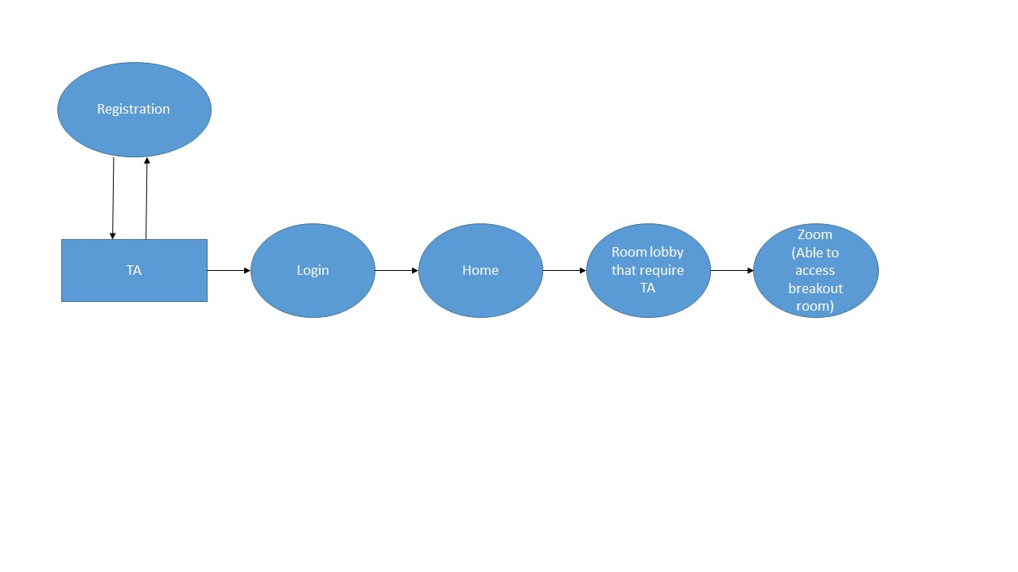

## Appendix B. Database Diagram

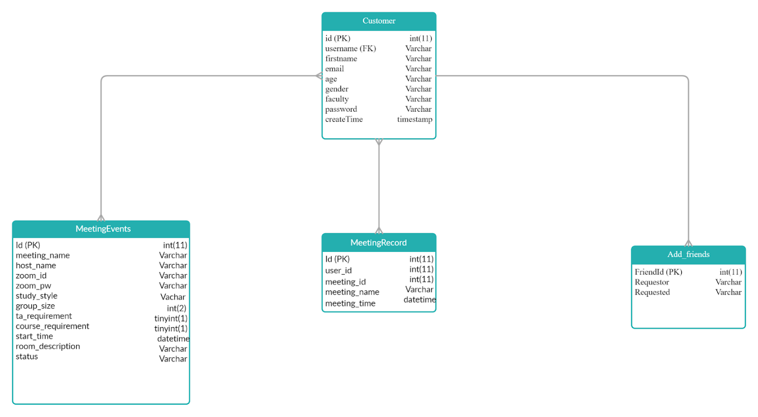

## Appendix C. Use-Case Diagram

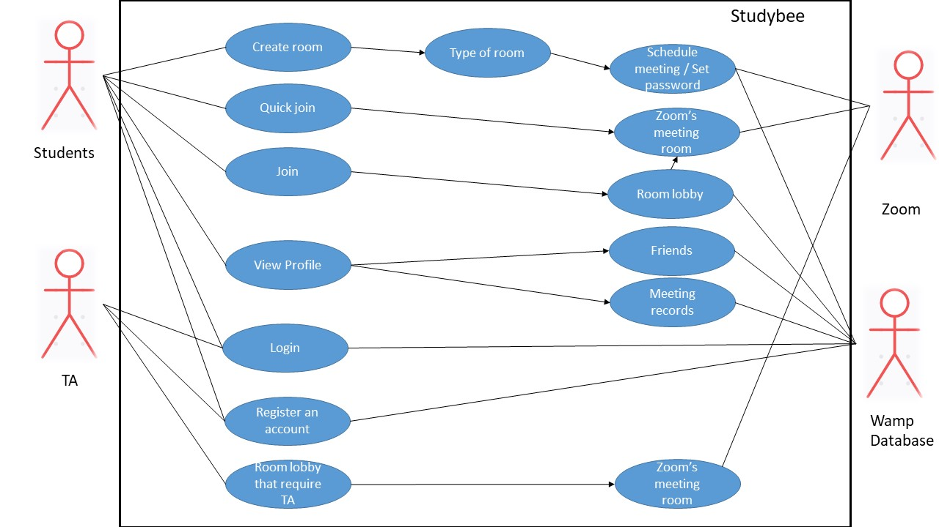

## Appendix D. Wire framing

Launch Page Login

 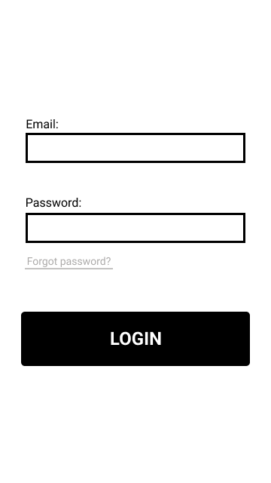

Register Home Screen

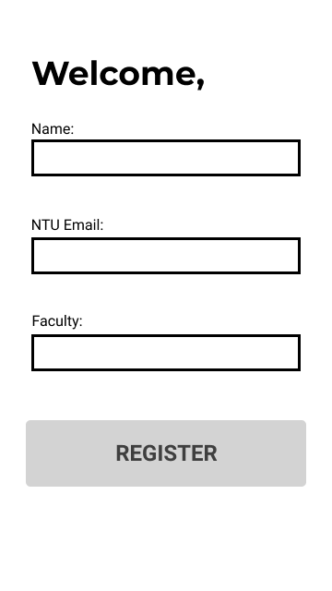 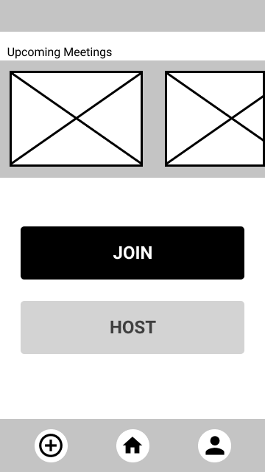

Host Screen Host Screen 2

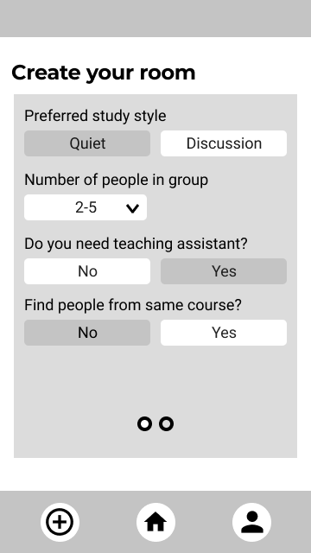 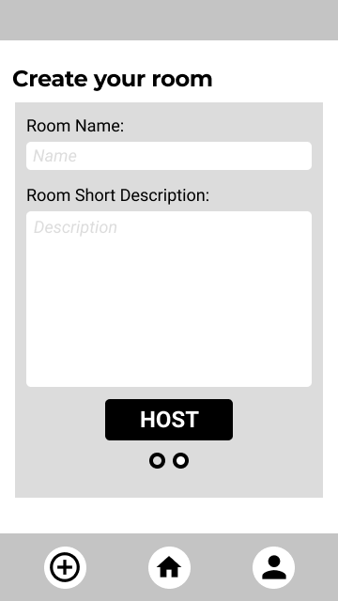

Join Screen Lobby

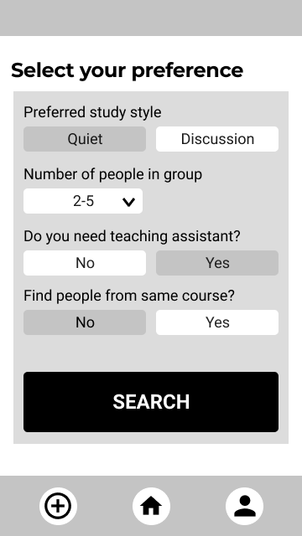 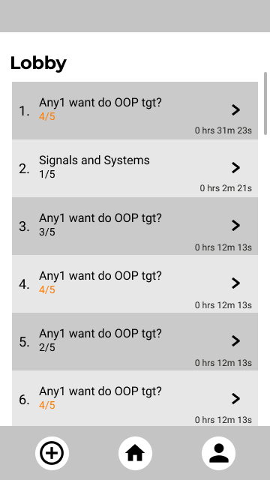

Room Description Screen Quick Join Screen

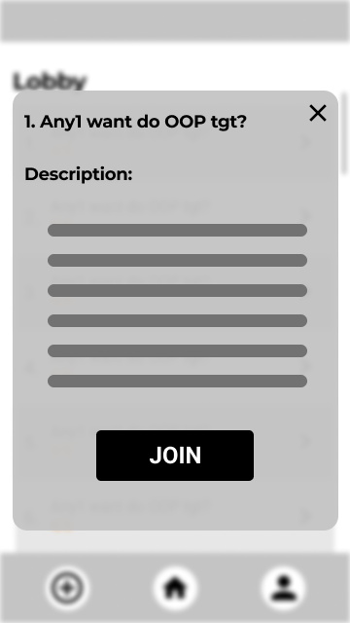 

Profile Info Screen Profile Records Screen

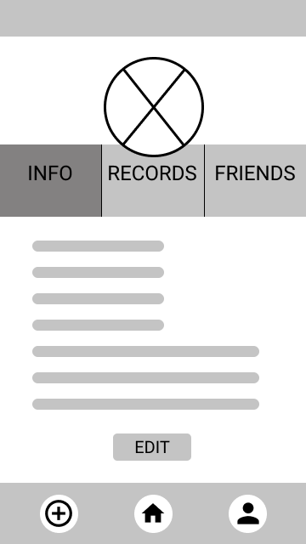 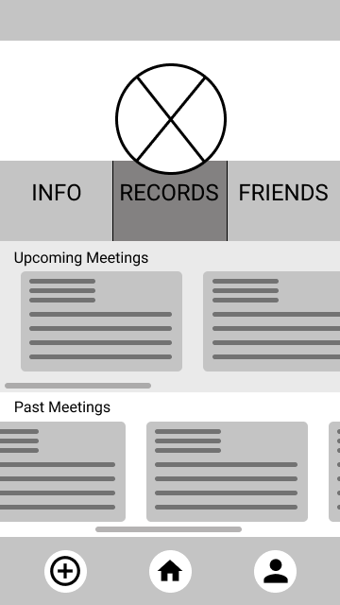

Profile Friends Screen Friends Pop-up Screen

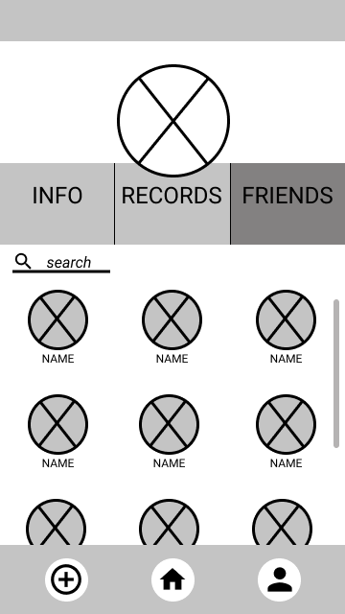 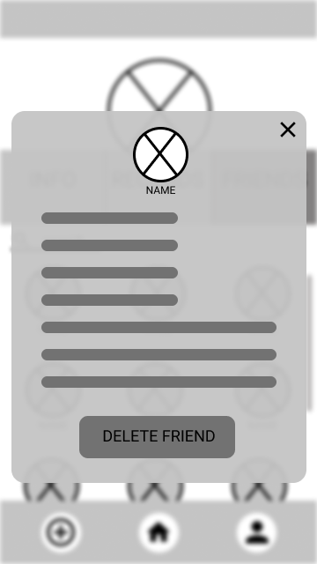

Overall

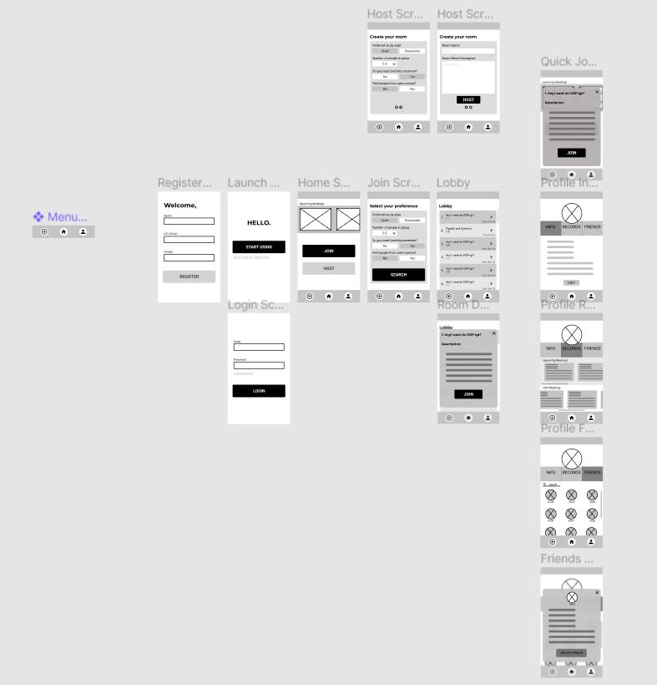

## Appendix E. Prototyping

Home Screen Join Screen

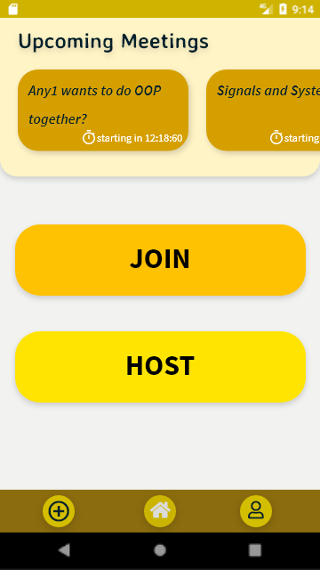 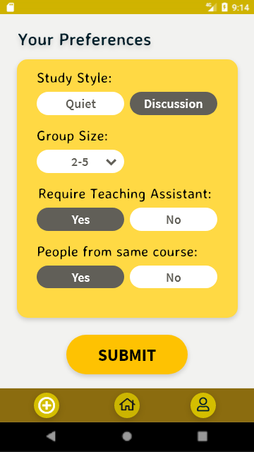

Lobby Room Description

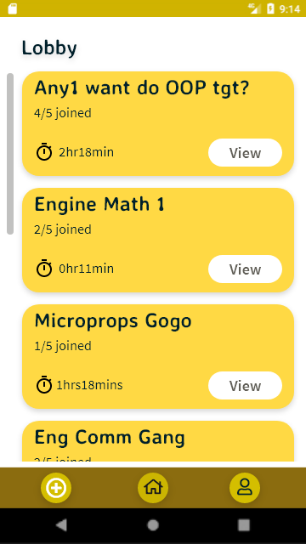 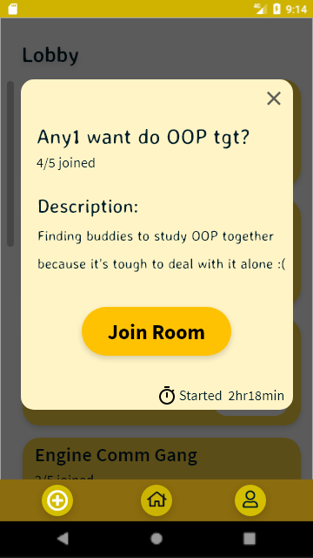

Zoom Login Profile – Info

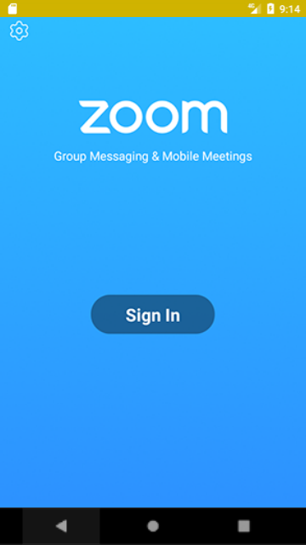 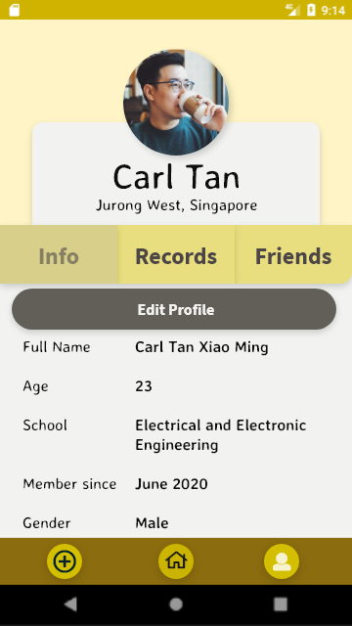

Profile – Records Profile – Friends

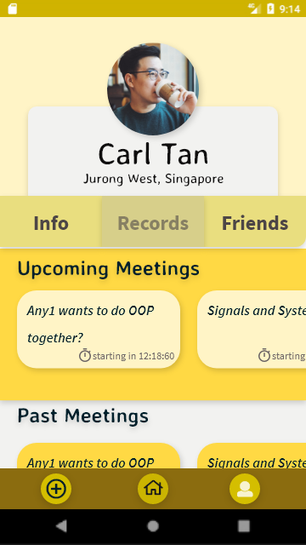 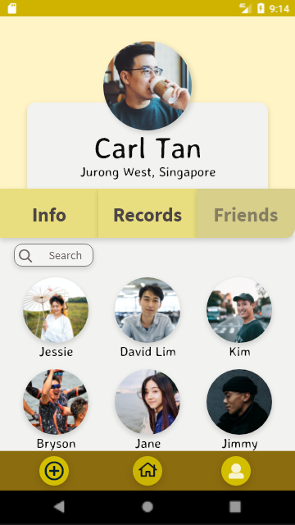

## Appendix F. Final Design

Login Screen Home Screen

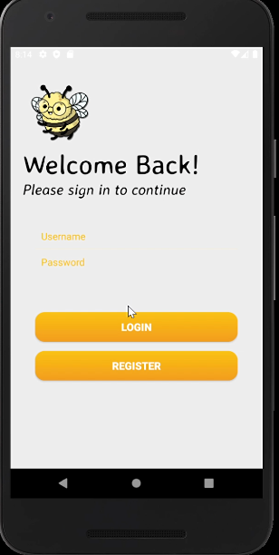 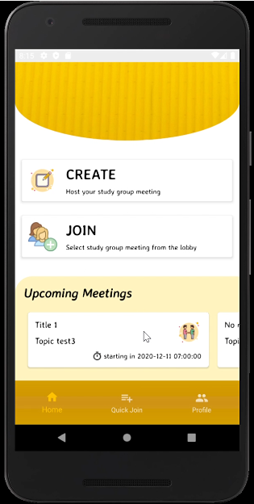

Profile Screen Change Profile Screen

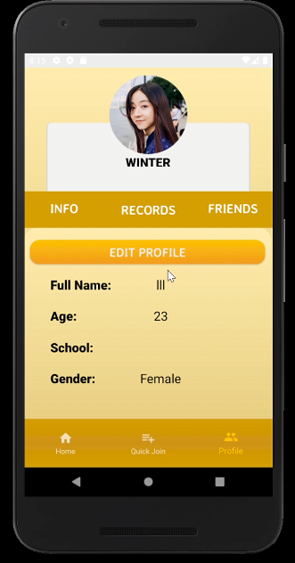 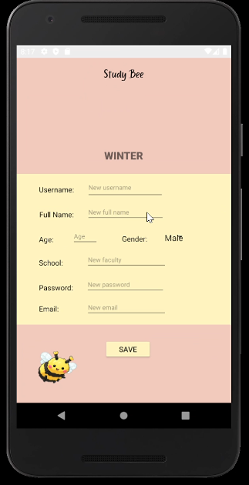

Meeting Records Friend Screen

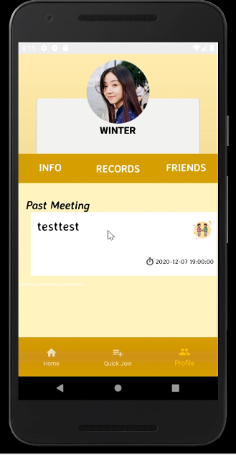 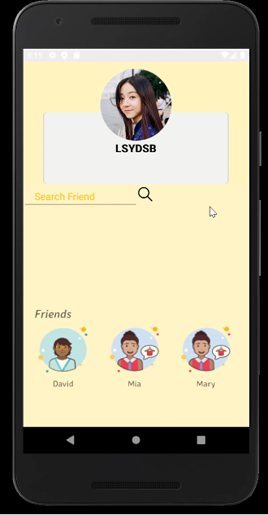

Add Friend Screen Create Room Screen

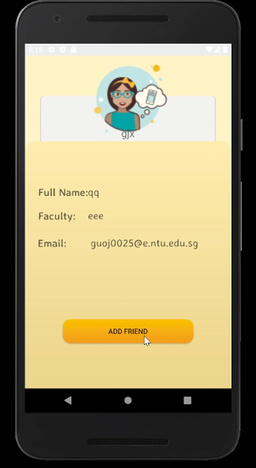 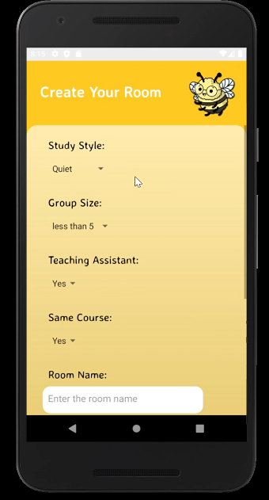

Zoom Login Page Join Room Screen

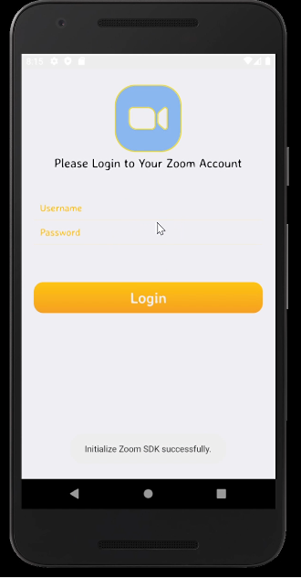 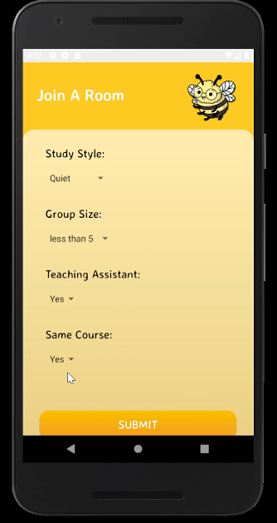

Lobby Screen

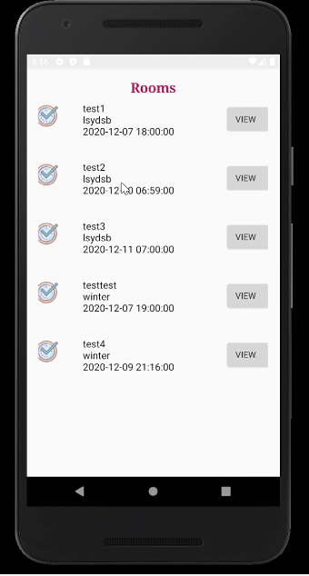

## Appendix G. Source Code

Full source code available on GitHub:

<https://github.com/DIP-Group5-StudyBee/StudyBeeGroup5>

### SDK initialization

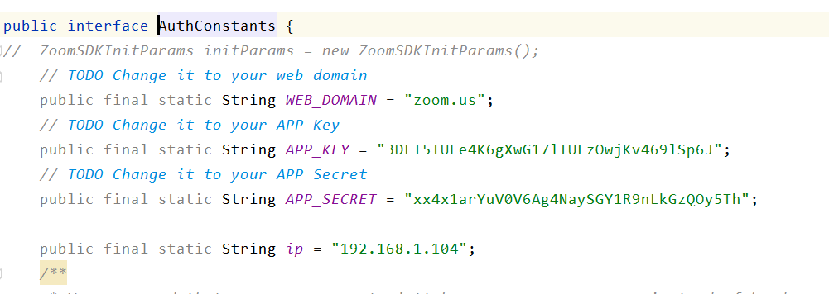

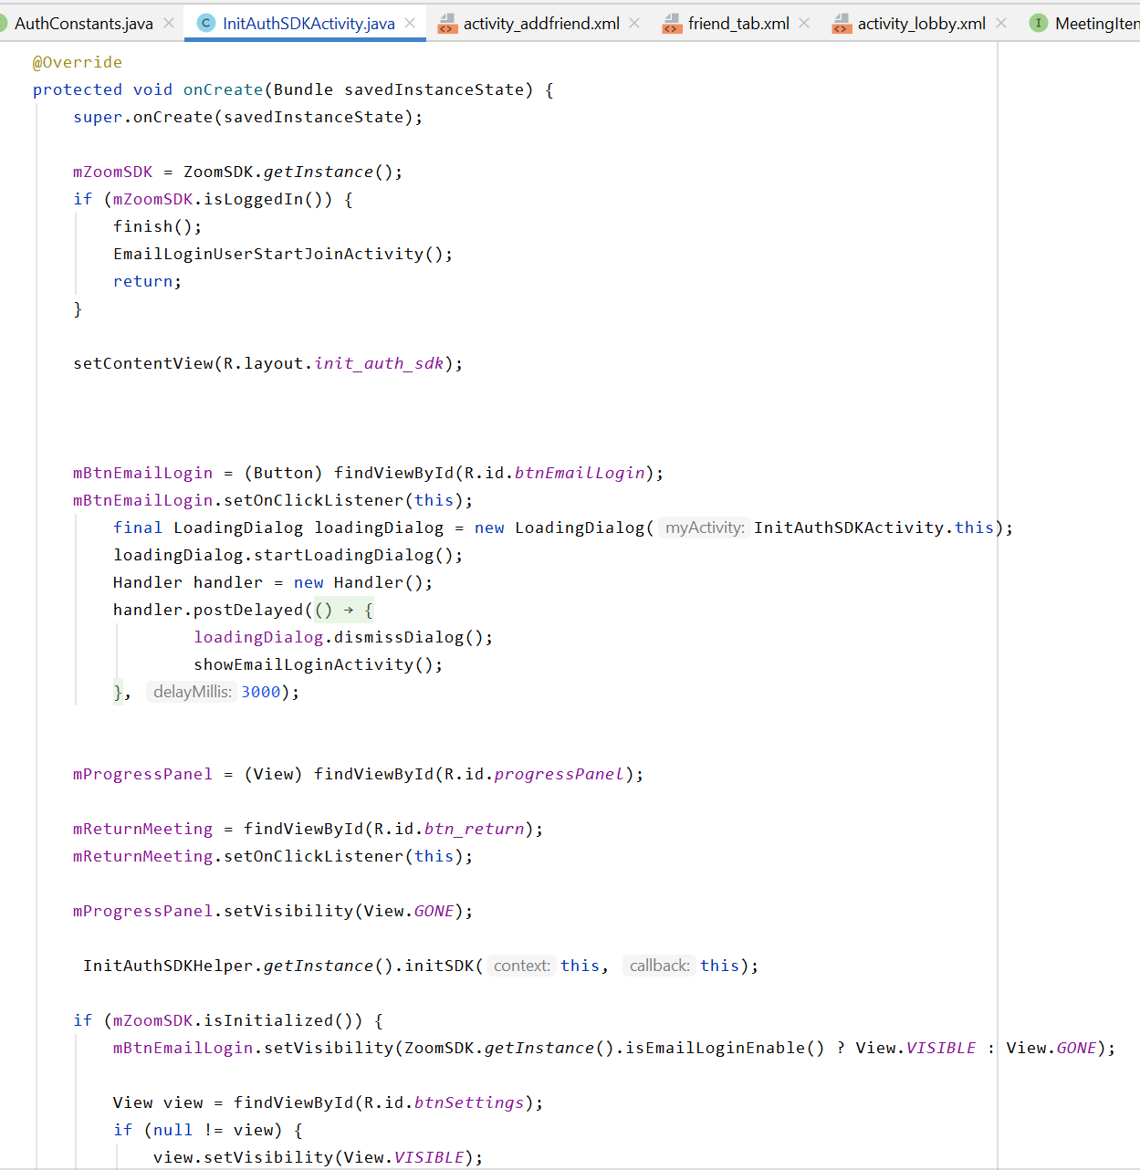

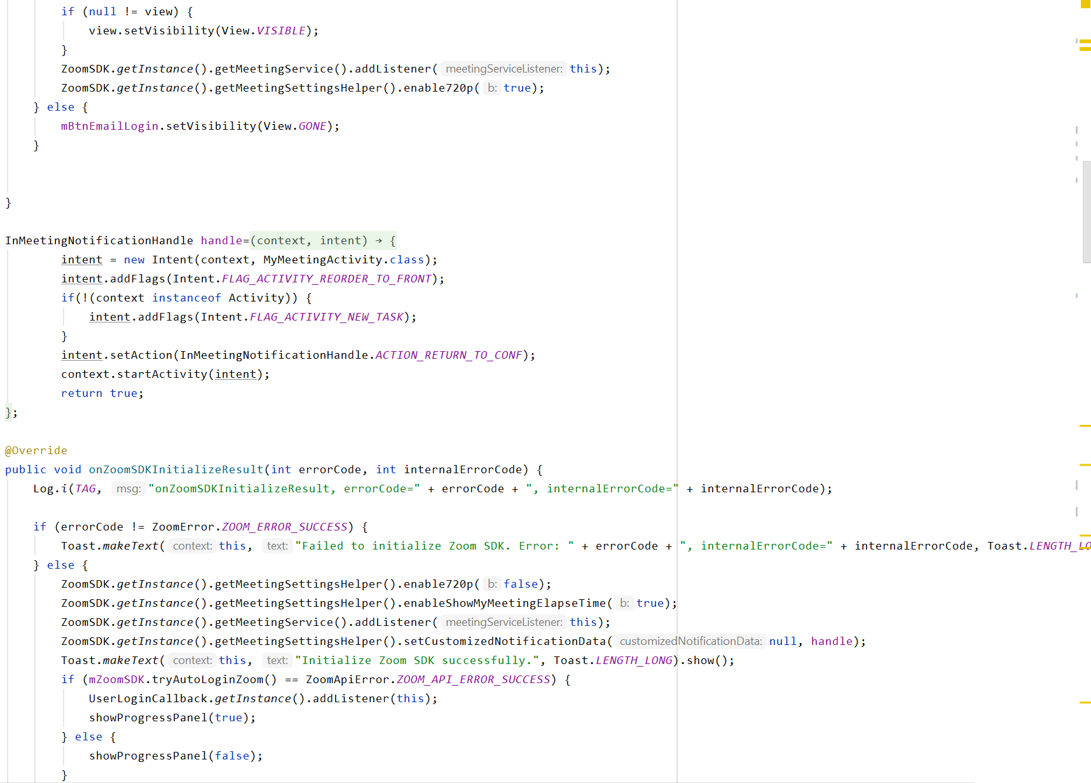

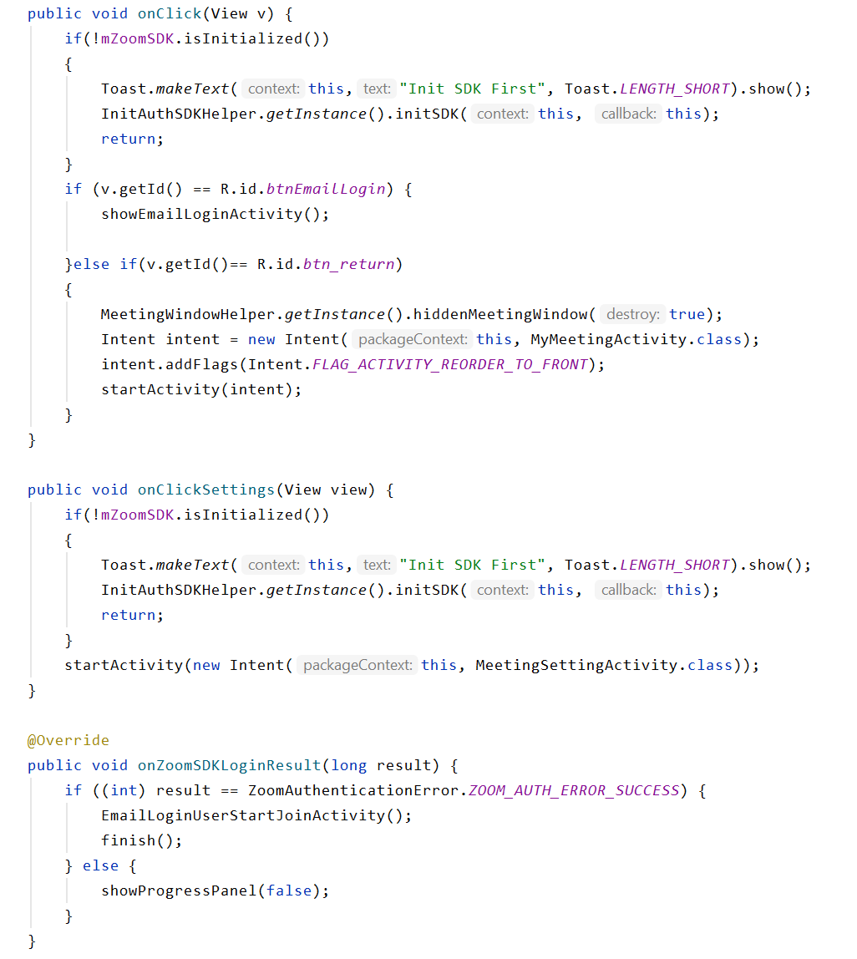

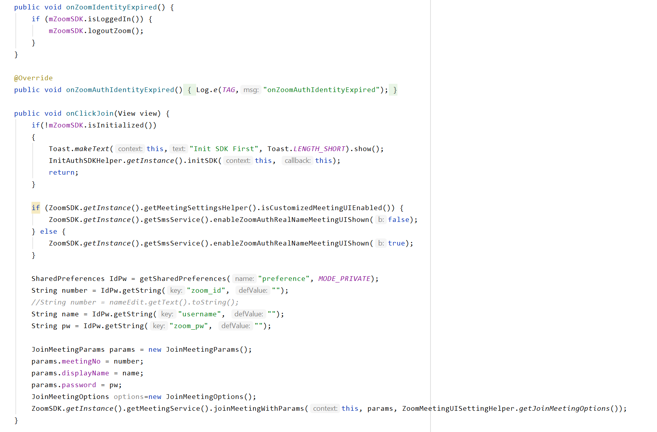

### Schedule meeting

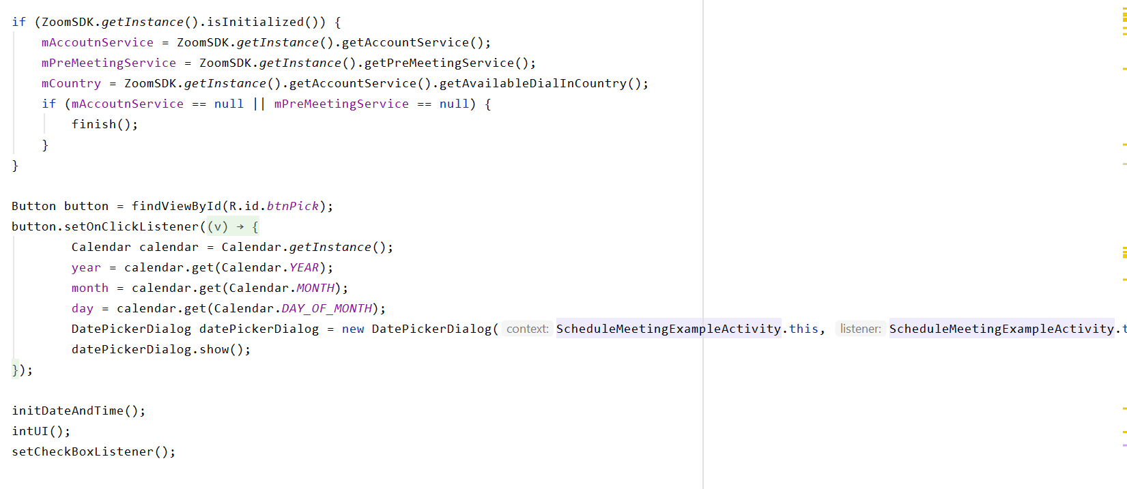

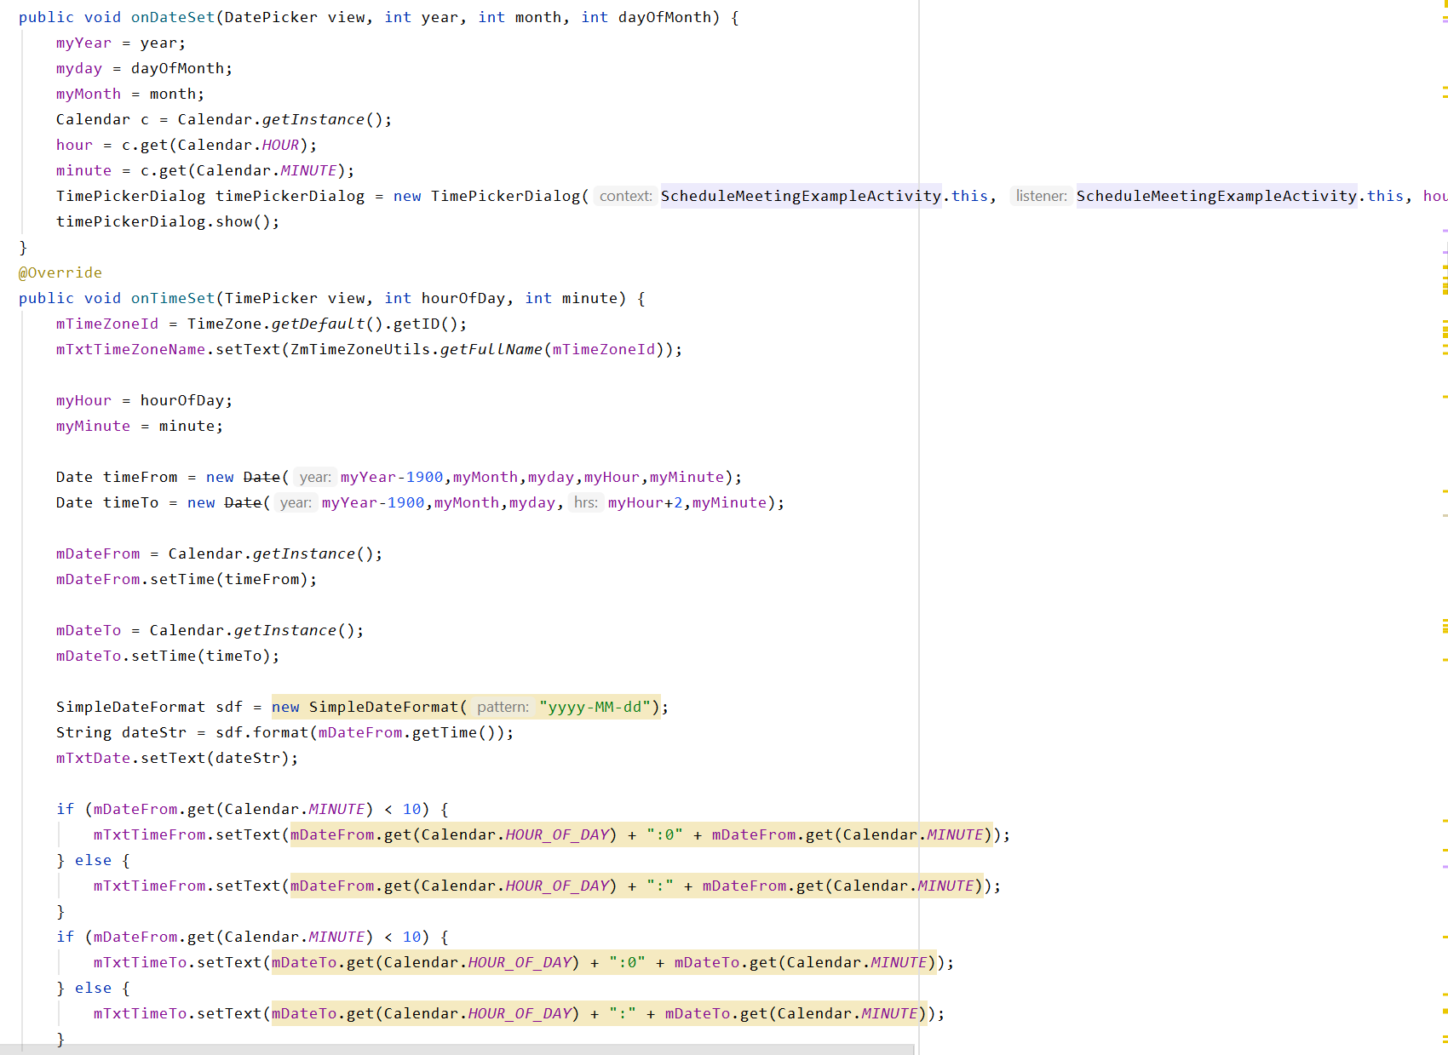

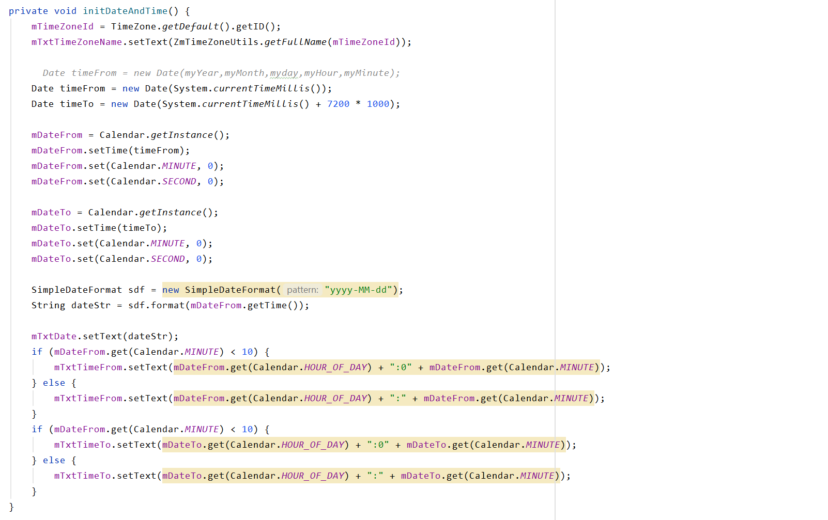

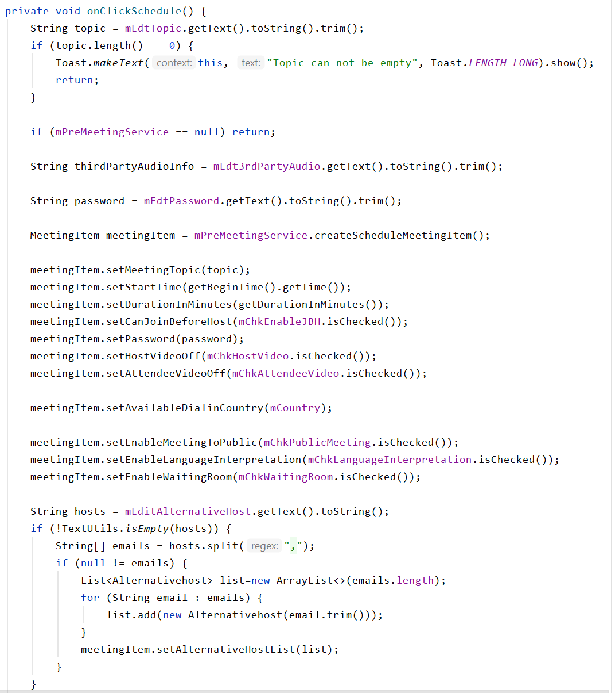

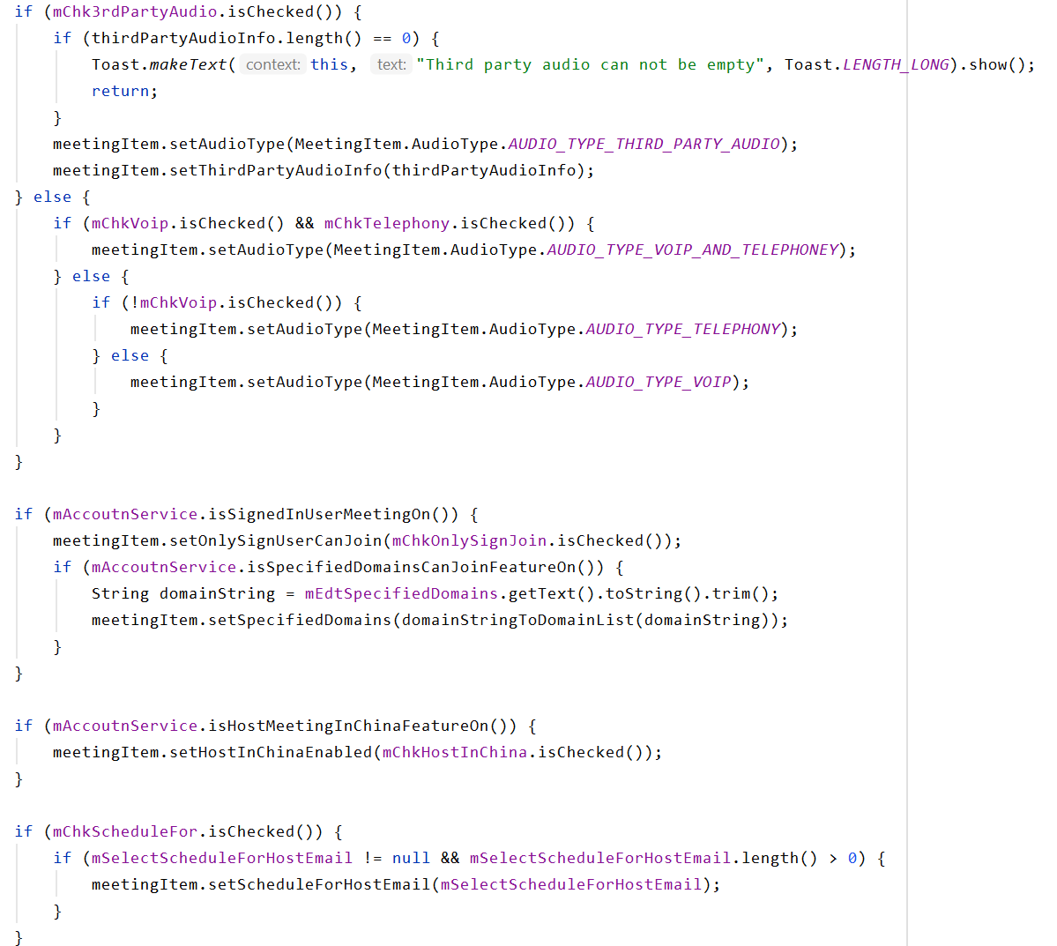

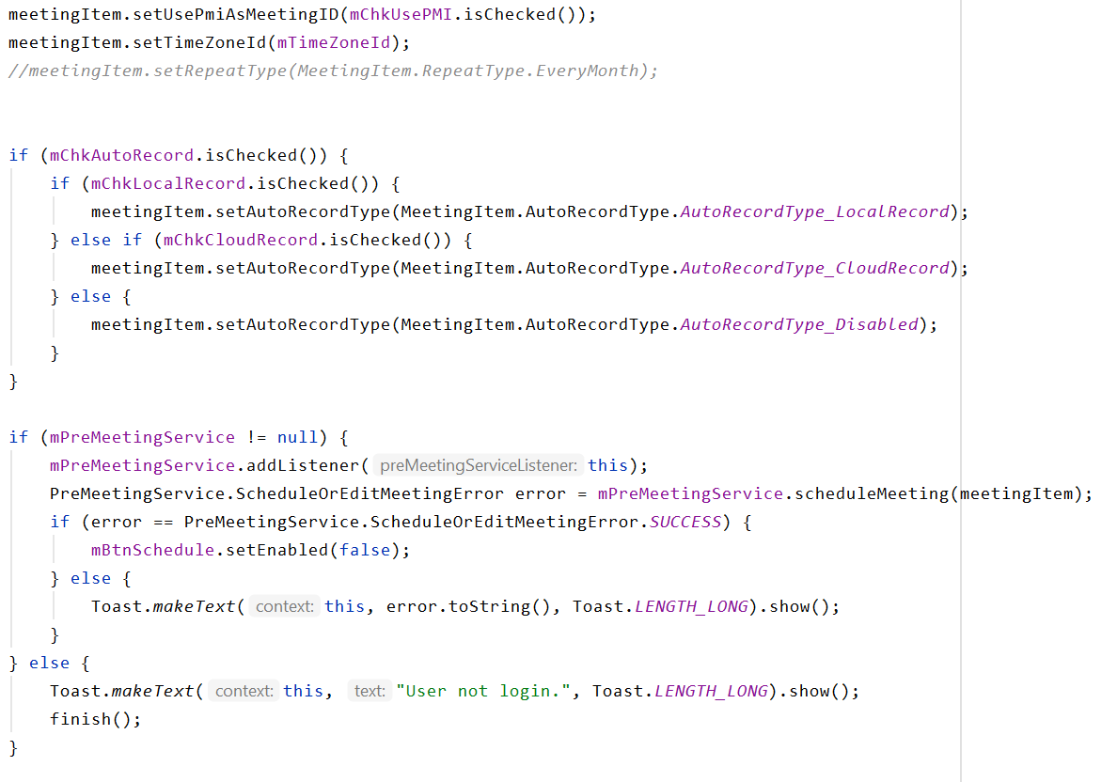

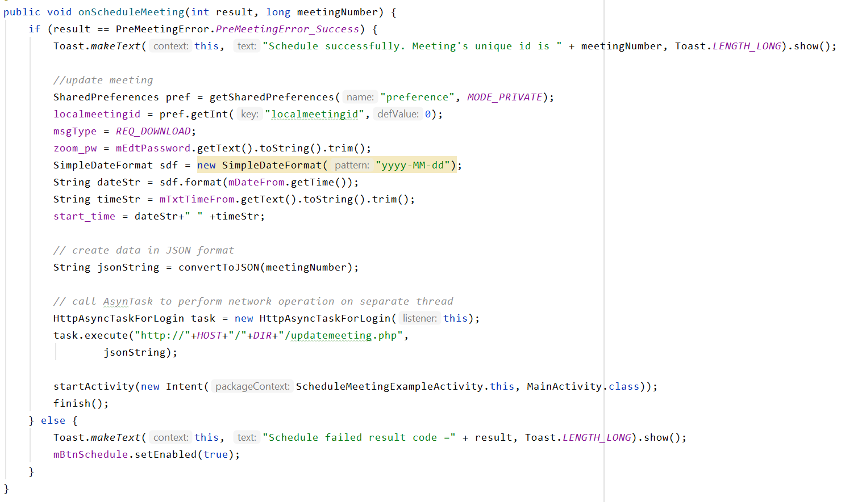

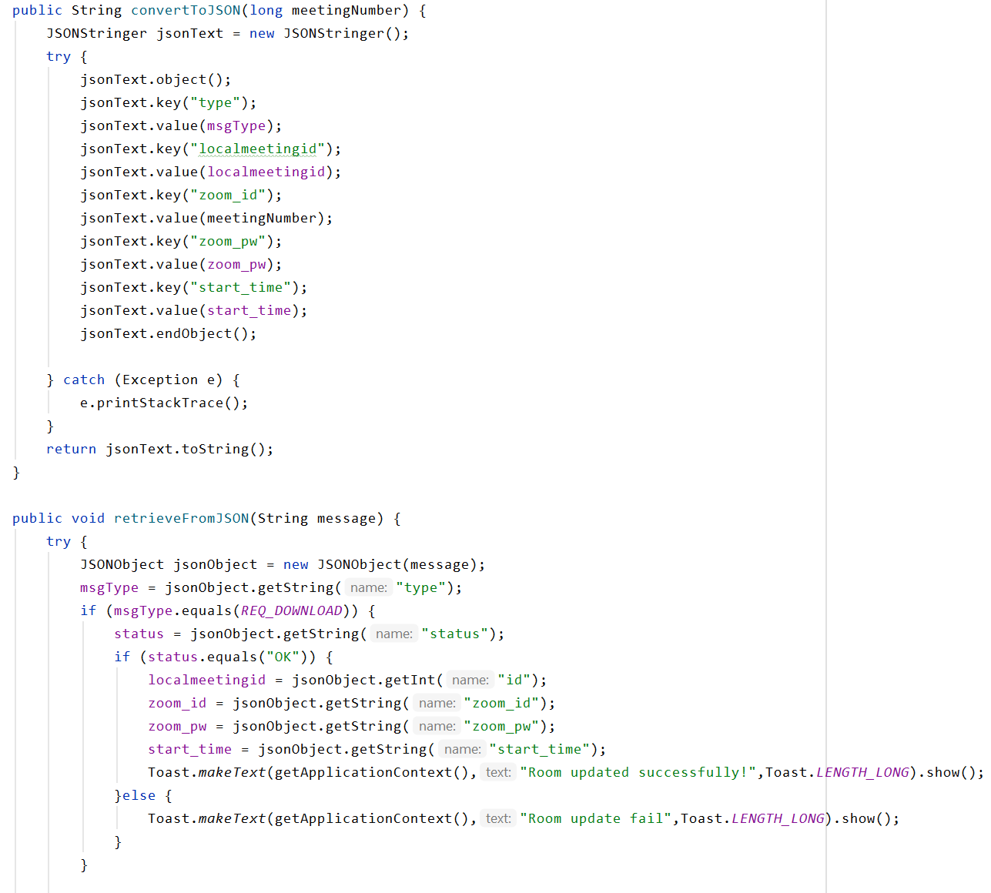

Delete rooms:

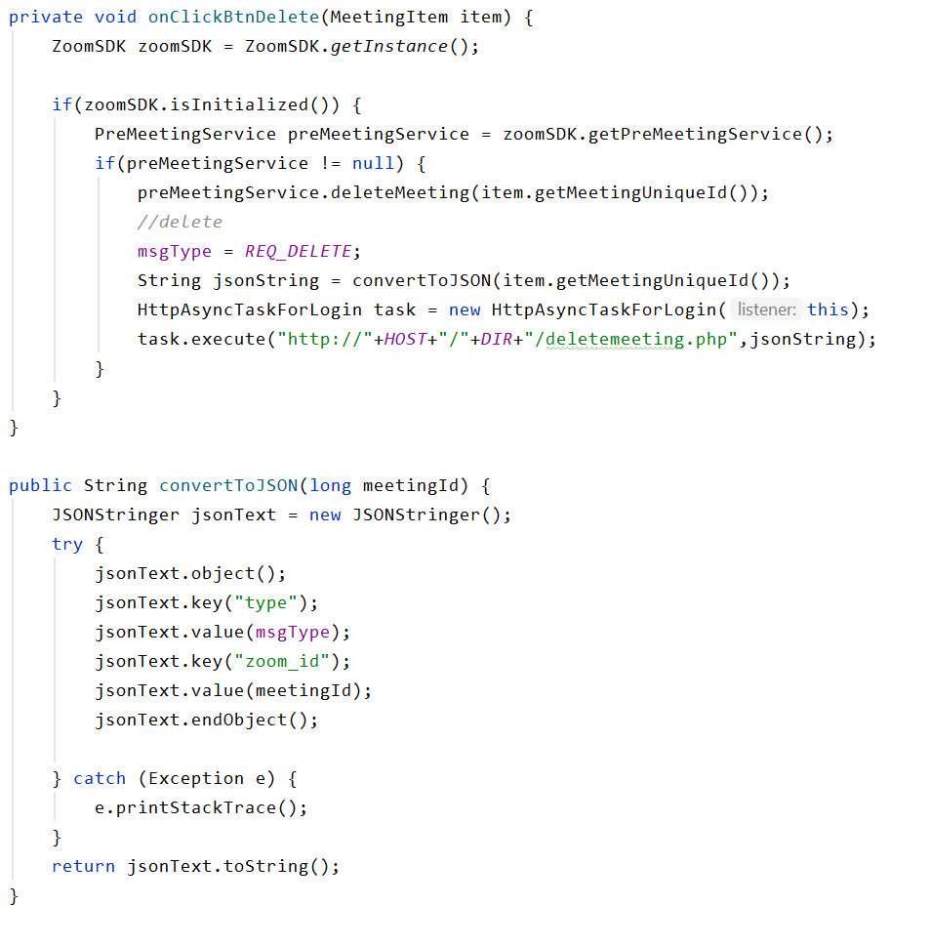

### Breakout Room

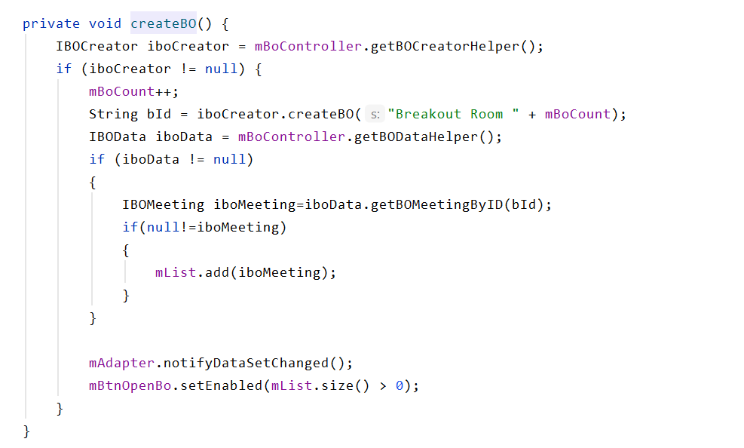

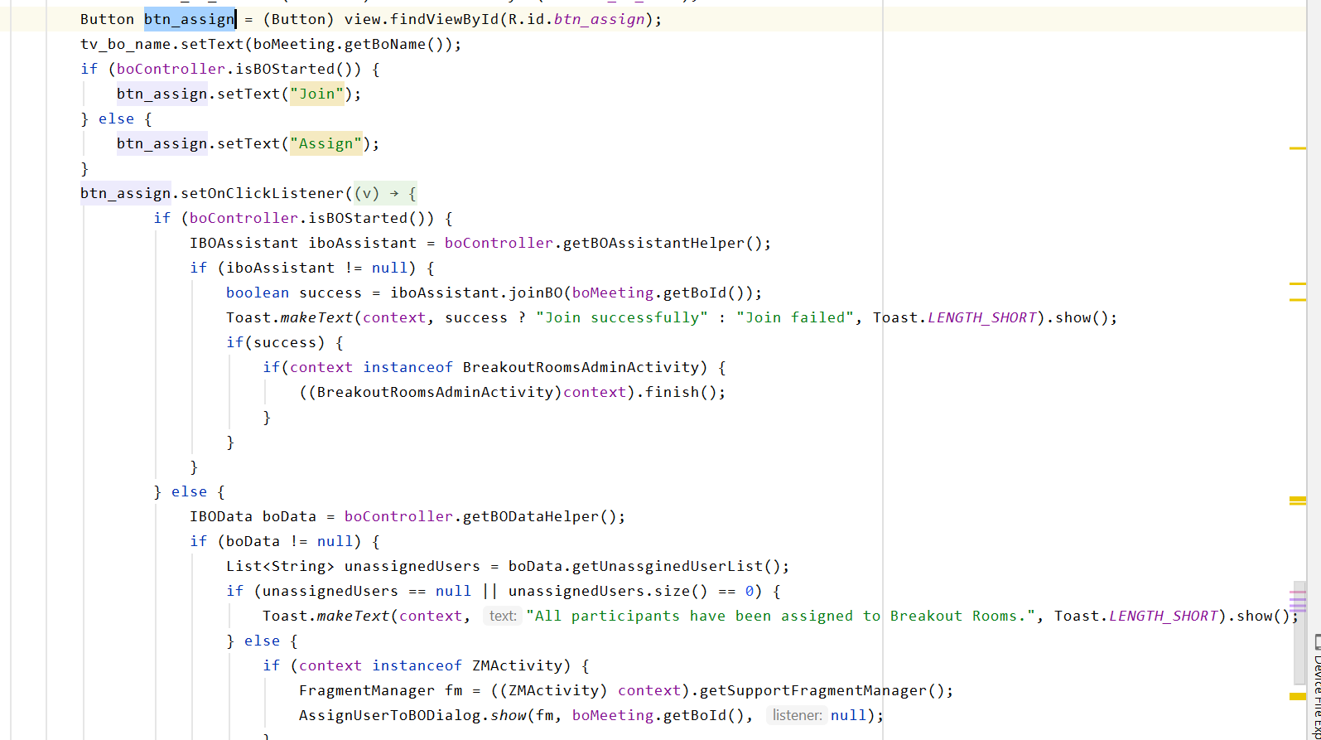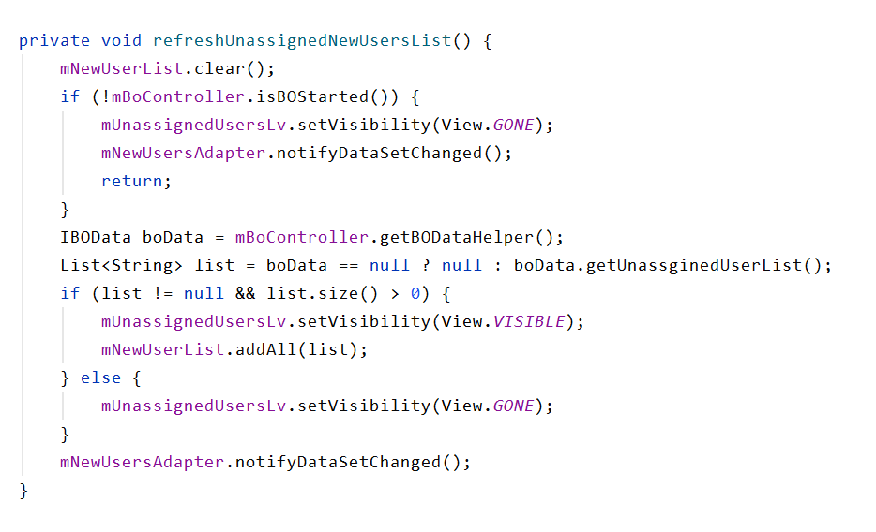

## Appendix H. User Guide

### Poster and virtual showcase

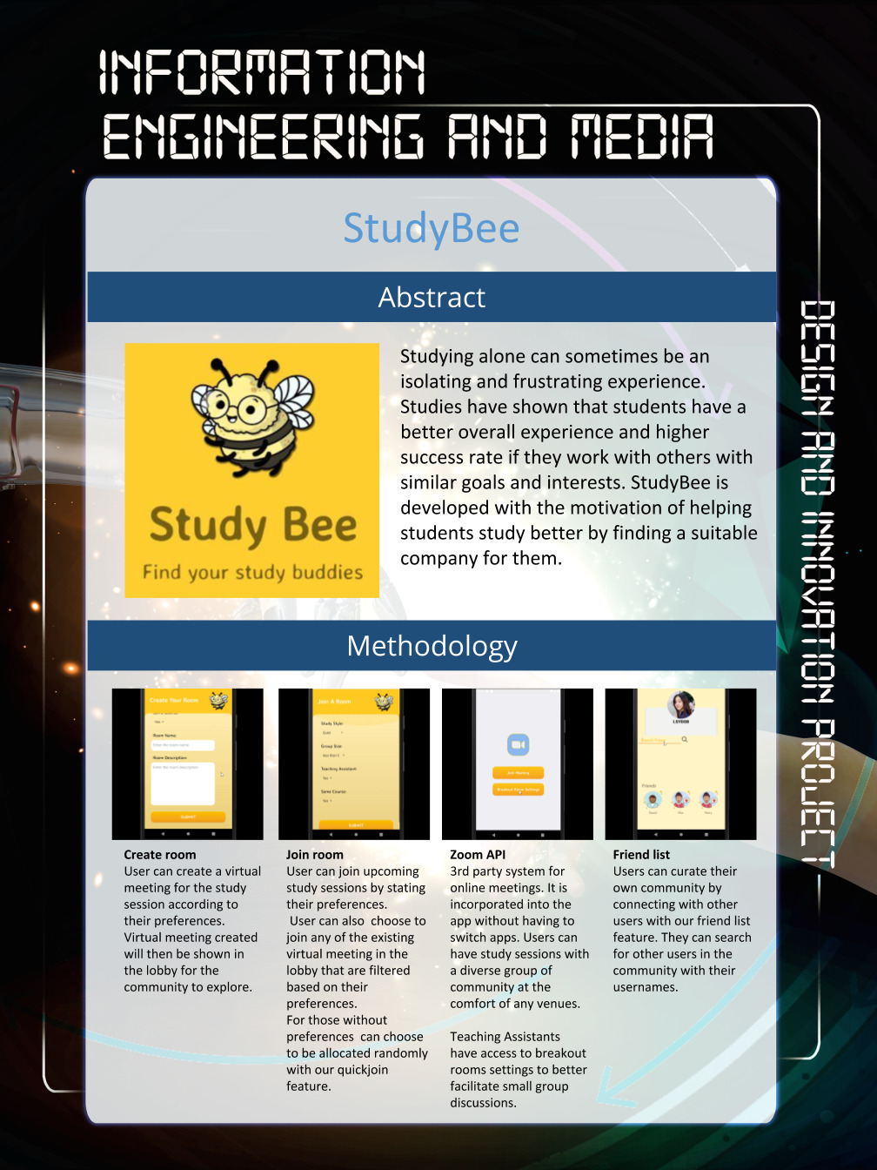

Visit [studybee.orgfree.com](http://studybee.orgfree.com/) for a virtual showcase and more information

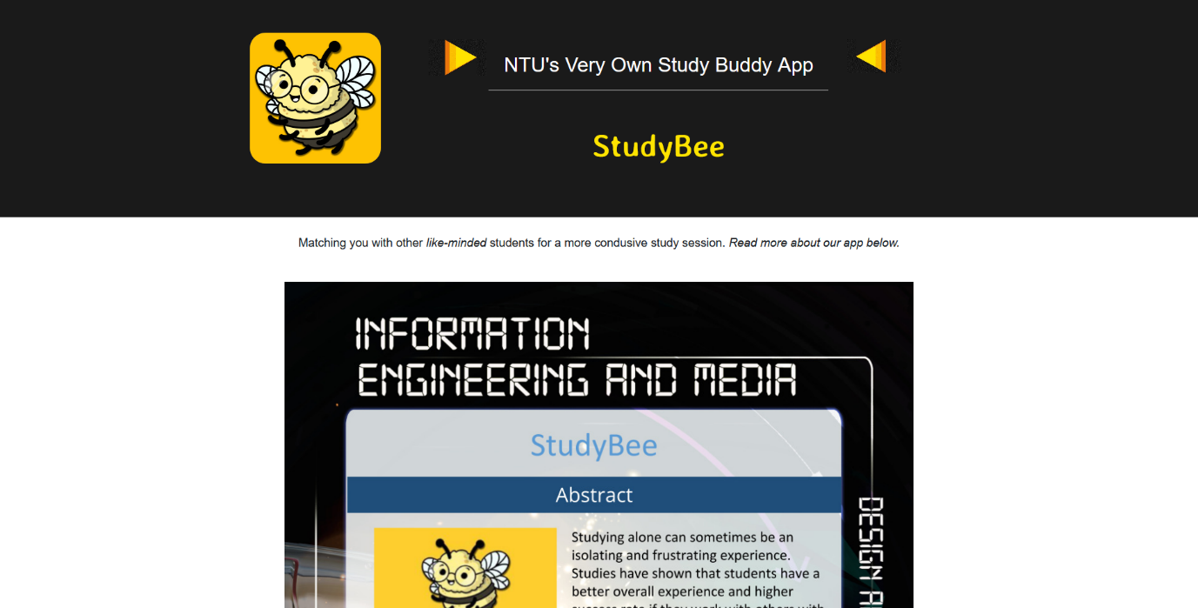

### Promotional video

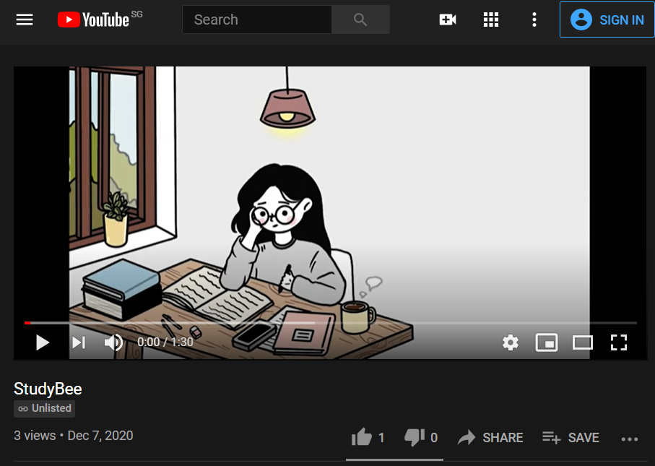

URL: <https://youtu.be/CsN8QrZxLm0>